Arkansas Game & Fish Commission
2 Natural Resources Drive Little Rock, Arkansas 72205

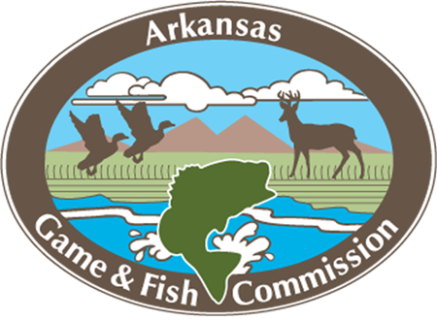

Austin Booth
Director

Doug Nygren
Reservoir Fisheries Habitat Partnership

RE: Letter of Support to Northwest Arkansas Fish Habitat Alliance Small Grant Application on Bob Kidd Lake

July 9, 2024

Dear Mr. Nygren,

We support the Northwest Arkansas Fish Habitat Partnership and Arkansas Game and Fish Foundations small grant proposal for improving fish habitat in Bob Kidd Lake. The lake is almost 50 years old and much of the woody fish habitat that was once in the lake is now gone. Fish habitat improvement projects like this one would greatly benefit the fishery and anglers that visit Bob Kidd Lake.

The AGFC will contribute to the project by committing $15,000 in funding to purchase Mossback Fish Habitat to place in Bob Kidd Lake and at least 3 other lakes in Arkansas. These projects will be linked to education and high school students will be constructing and placing the habitat structures. The project will greatly improve fish habitat in the lake and fulfill our goals in the Bob Kidd Lake Fisheries Management Plan.

Sincerely,

Jon Stein
District Fisheries Supervisor
2805 West Oak Rogers, AR 72758
479-640-6422

