Lake Bob Kidd

Washington County

Fishery Management Plan - 2019

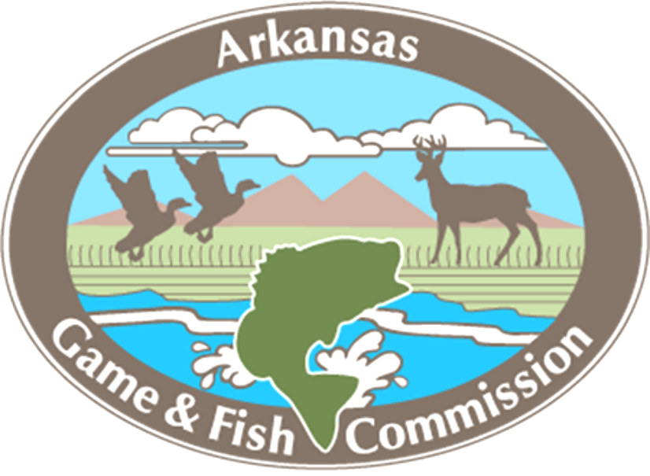

Fisheries Division
Rogers Field Office

Jon E. Stein, District Fisheries Supervisor

Kevin D. Hopkins, District Management Biologist
Bob Kidd Lake Fishery Management Plan
2019

Background

Bob Kidd Lake (sometimes called Budd Kidd Lake) is an 81-hectare (200 acre) impoundment owned by the Arkansas Game and Fish Commission. It was constructed in 1976, has an average depth of four meters (13 ft.) and a maximum depth of 9.5 meters (31 ft.). There is a pronounced creek channel along the south bank, marked by an abundance of standing timber. The upper one-third of the lake is very shallow (one meter or less) and contains water lily and other emergent plants. The banks are gently sloping mud, clay, and shale with little gravel. Currently Bob Kidd Lake Largemouth Bass fishing is regulated with a 330-406 mm (13-16”) slot limit.

Bob Kidd Lake is a popular fishery for crappie, Bluegill, Redear Sunfish, Largemouth Bass and Channel Catfish. The lake is one of the best lakes in northwest Arkansas to catch pan sized Bluegill and Redear Sunfish. Redear Sunfish over 1 pound are routinely collected while sampling. Bob Kidd Lake has a very good Channel Catfish population that is maintained via regular stocking. The lake has an ample forage base to support a large number of predators, and forage consists of Gizzard Shad, sunfish and various minnow species. Bob Kidd Lake has been sampled by AGFC biologists for many years using a variety of gears (Tables 1-3). Boating access is provided by a one-lane concrete ramp near the dam. Shoreline fishing access is available around the majority of shoreline, but the most popular areas include the fishing dock, dam and new fishing access on the north end of the lake.

Management History

Fertilization was important for increasing productivity in the lake from 2000-2007, but many high water events (2008, 2011, 2013, 2015, 2017, and 2018) brought many nutrients into the lake. Fertilization has not be completed since 2007 due these increased nutrient levels and good productivity. The Largemouth Bass population has been regulated with a 13-16 inch minimum length limit for over 20 years. The goal of this regulation is to allow harvest of small bass and protect fish in the 13-16 inch range.

The lake has good amounts of shoreline vegetation consisting of lily pads and water willow. However, lily pads have been non-existent since winter flooding of 2015. The water willow and other aquatic vegetation has been a great benefit to fish production in Bob Kidd Lake.

GOAL

Promote and enhance the fishing experience at Bob Kidd Lake with an emphasis on managing sportfish populations that are acceptable to a majority of anglers under existing and future fishing pressure.

Objective 1: Increase approval rating (satisfaction) with Bob Kidd Lake anglers.

Action: Provide at least 1 media-related news release every 3rd year promoting the existing fish population. Promote fishing opportunities via local television, newspaper, Arkansas Outdoors, etc.
Expectation: Angler usage will increase.
Evaluation: Obtain feedback from anglers through personal communications and access creel surveys.

Objective 2: Improve angler access to Bob Kidd Lake.

Action: Work with Regional Maintenance Contract Coordinator to improve bank fishing access by increasing mowing contract to mow trails to the dam, the inside levee of the dam and new bank fishing access developed in 2018 at least 3 times per year. Ensure that the whole levee is mowed at least 1 time per year.
Action: Acquire funding for new fishing pier at access road on north side of the lake.
Action: Work with local groups to improve access areas through volunteer activities (trash pick-up, clearing trails, etc.).
Expectation: Bob Kidd Lake will attract more anglers and anglers will have cleared bank fishing access to the lake, thus increasing satisfaction.

Objective 3: Maintain Largemouth Bass electrofishing catch per unit of effort ≥ 190 bass/hr (75th percentile for highland lakes) to promote a high-quality panfish fishery.

Action: Adjust regulations as dictated by population size structure and abundance.
Expectation: Bob Kidd Lake will support a robust Largemouth Bass fishery with high angler catch rates.
Evaluation: Sample the lake using spring electrofishing every three years to evaluate the Largemouth Bass population.

Objective 3: Promote and enhance the panfish fishery on Bob Kidd Lake by achieving a crappie mean length at age-2 of 200 mm (median for highland lakes).

Action: Continue to manage the lake as a quality Bluegill, Redear and crappie fishery.
Action: Publicize the panfish efforts in local media.
Expectation: Panfish fishing will continue to be very good in the lake.
Evaluation: Evaluate the Bluegill, Redear and crappie fisheries every 3rd year with trap nets.

Objective 4: Promote and enhance the recreational catfish fishery on Bob Kidd Lake by maintaining a hoop net CPUE of > 11/series (median for AR lakes).

Action: Publicize catfish management efforts in local media.
Action: Stock 4,000 yearling Channel Catfish per year depending on hoop net catch rates.
Expectation: Catfish angling will become more popular on Bob Kidd Lake and
targeted effort will increase.
Evaluation: Use tandem baited hoop-nets every three years to assess trends in Channel Catfish population and assess stocking efficacy.

Objective 5: Monitor and increase the density of the forage population.

Action: Sample the forage populations in Bob Kidd Lake by community electrofishing sample.
Evaluation: Complete community fish population samples every 3rd year to evaluate and monitor the forage population.
Evaluation: Monitor productivity (secchi readings) and fertilize the lake if needed.
Evaluation: Evaluate the Gizzard Shad population and if there are too many large fish, conduct a low dose rotenone sample to reduce the population.
Expectation: Reducing the size of the adult Gizzard Shad population should increase Bluegill populations.

Objective 6: Maintain and improve fish habitat on Bob Kidd Lake.

Action: Maintain current natural habitat structures by adding additional brush every 5 years.
Action: Improve fish habitat by adding an additional 10 new fish habitat sites in the next 5 years. All sites will be included on the following website: https://gis.agfc.com/
Expectation: Improve angler satisfaction and improve angler catch rates on Bob Kidd Lake.
Evaluation: Conduct an access creel survey in spring 2021

Objective 7: Conduct a public meeting to obtain input from the public on the management plan.
Action: Hold a public meeting in Prairie Grove to obtain public input within the next 3 years.
Expectation: Angler satisfaction will increase as a result of being included in the management plan process.
Evaluation: Public meeting is held or not.

Table 1. Bob Kidd Lake sampling history.

Year | Spring Electrofishing | Tandem Hoop Nets | Shoreline Seining
2010 | X
2011
2012 |  | X
2013 | X | X | X
2014 |  | X | X
2015
2016 | X
2017 |  | X
2018

Table 2. Electrofishing data summary for Largemouth Bass from Bob Kidd Lake.
 | CPUE (#/hr) | PSD | PSD-P | Age-1 CPUE
2010 | 138 | 52 | 26
2012 | 175 | 35 | 8 | 36
2013 | 179 | 29 | 7 | 16
2014 | 245 | 62 | 7
2015 | No Sample
2016 | 249 | 79 | 21
2017 | No Sample
2018 | No Sample

Table 3. Channel Catfish hoop net data summary from Bob Kidd Lake.
 | CPUE (#/series) | PSD | PSD-P
2010¹ | 6 | 100 | 25
2012¹ | 0.6 | 100 | 50
2013 | 17 | 18 | 15
2014 | 10 | 70 | 15
2015¹
2016
2017 | 16 | 62 | 1
2018

Table 4. Fish stocking record for Bob Kidd Lake since 2009.

Date | Species | Size | # Stocked
7/21/2009 | Channel Catfish | Catchable | 600
10/8/2009 | Blue Catfish | Yearling | 1,003
3/5/2010 | Channel Catfish | Catchable | 600
11/10/2010 | Grass Carp | Yearling | 300
7/11/2011 | Channel Catfish | Catchable | 600
2/28/2012 | Grass Carp | Yearling | 300
5/15/2012 | Channel Catfish | Catchable | 597
10/30/2012 | Channel Catfish | Catchable | 788
11/14/2013 | Channel Catfish | Yearling | 4,000
10/24/2013 | Channel Catfish | Catchable | 600
10/11/2013 | Black Crappie | Yearling | 20,000
10/14/2014 | Channel Catfish | Yearling | 4,000
10/22/2014 | Black Crappie | Yearling | 11,772
6/19/2014 | Largemouth Bass | Fingerling | 7,980
10/16/2014 | Channel Catfish | Catchable | 600
12/2/2015 | Black Crappie | Fingerling | 13,525
9/16/2015 | Channel Catfish | Yearling | 4,000
4/21/2016 | Channel Catfish | Yearling | 4,000
4/19/2017 | Channel Catfish | Yearling | 4,000
4/12/2018 | Channel Catfish | Yearling | 6,000

