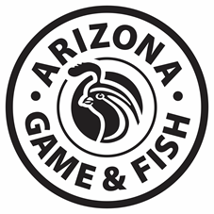

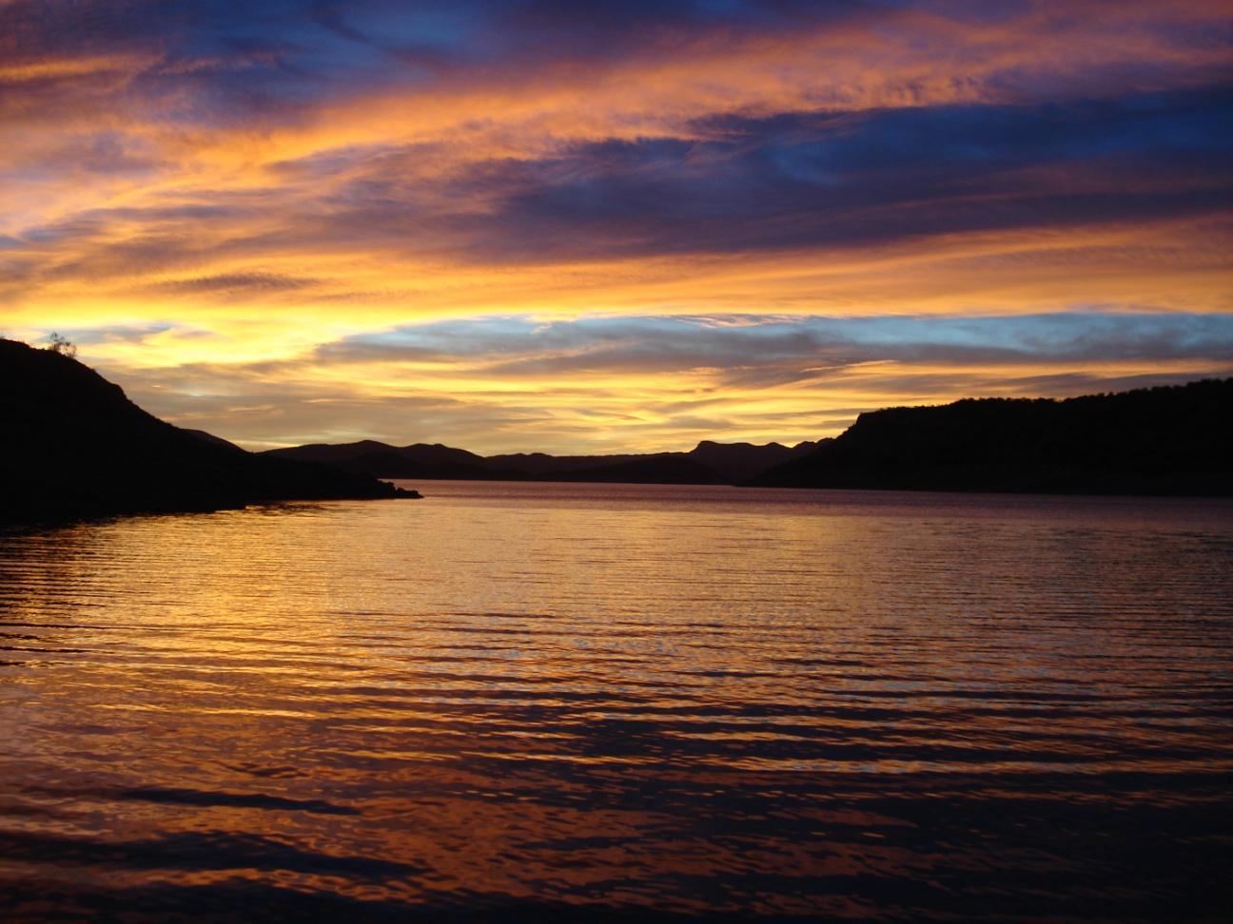

Saguaro Lake
Fisheries Management Plan
2020-2030
Curt Gill, Aquatic Wildlife Program Manager, Region VI

The Arizona Game and Fish Department (AGFD) prohibits discrimination on the basis of race, color, sex, national origin, age, or disability in its programs and activities. If anyone believes that they have been discriminated against in any of the AGFD's programs or activities, including its employment practices, the individual may file a complaint alleging discrimination directly with the Directors Office, 5000 W. Carefree Hwy, Phoenix, AZ 85086-5000, (602) 942-3000 or U.S. Fish and Wildlife Service, Attn: Civil Rights Coordinator for Public Access, 5275 Leesburg Pike, MS:WSFR, Falls Church, VA 22041-3803.

Persons with a disability may request a reasonable accommodation or this document in an alternative format by contacting the Director’s Office as listed above.
Location
Saguaro Lake is located just below the Mormon Flat Dam and is the lowermost of four reservoirs on the Salt River. Saguaro Lake can be reached from the Bush Highway either from Mesa, AZ or from the Bee Line Highway (SR 87).

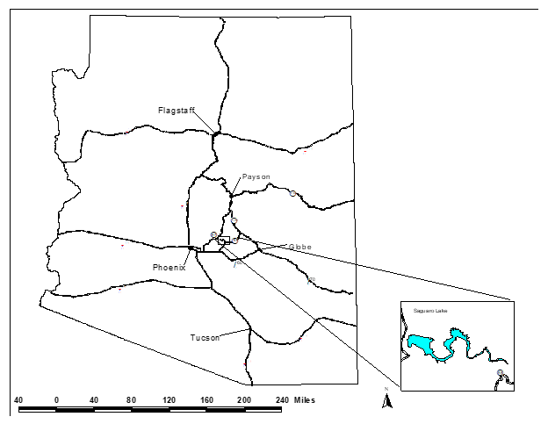
Figure 1. Location map of Saguaro Lake in central Arizona.

Management Prescription
The Arizona Game and Fish Department (Department) has developed approaches under a Warmwater Strategic Vision Document (AGFD 2019a) to help guide warmwater fisheries management in Arizona. Using these approaches, fisheries management at Saguaro Lake will focus primarily on a AZ Hawg Bass Largemouth Bass Micropterus salmoides fishery, secondarily to manage for a High Quality Catfish water for Channel Catfish Ictalurus punctatus and thirdly on a Featured Species opportunity fishery for Yellow Bass Morone mississippiensis. Additionally, the lake will be managed for a seasonal Intensive Use Rainbow Trout Oncorhynchus mykiss fishery as described in the Department’s Coldwater Sportfisheries Strategic Vision Document (AGFD 2019b).
Objective 1: Maintain the Largemouth Bass population to meet or exceed AZ Hawg standards.
Objective 2: Maintain the Channel Catfish population to meet or exceed High Quality Catfish standards.
Objective 3: Maintain the Yellow Bass population to meet or exceed Featured Species standards.
Objective 4: Maintain a seasonally (November to March) stocked Rainbow Trout fishery to meet or exceed Intensive Use standards.
Objective 5: Maintain angler satisfaction at 80%.
Monitoring activities, including community-wide or species-specific electrofishing surveys and angler creel surveys will be used to determine if aforementioned management objectives are being met. Objective guidelines to meet objectives are listed in Table 1 below.
Table 1. Saguaro Lake Objectives and Adaptive Management Strategies.
Objective 1: Maintain the Largemouth Bass population to meet or exceed AZ Hawg standards.
Parameters |  | Objective Guideline |  | Trigger point to address unmet objectives | Strategies if Objectives are not met
Electrofishing Catch Rates |  | Spring electrofishing CPUE¹ ≥ 50 fish per hour. |  | Mean CPUE drop below 50 fish/hour for three consecutive surveys.  Mean CPUE drops below 10 fish/hour for a single sampling event. | - Re-evaluate survey methods and equipment  - Stocking  - Regulation Changes
Parameters |  | Objective Guideline |  | Trigger point to address unmet objectives | Strategies if Objectives are not met
Size Structure |  | PSD² between 50-80, PSD-P³ between 30-60, and PSD-M⁴ between 10-25. |  | Three consecutive sampling events showing population below management guideline. | - Re-evaluate survey methods and equipment  - Stocking  - Regulation Changes
Angler Catch Rates |  | Angler CPUE of no less than 0.25 fish per hour for anglers targeting Largemouth Bass. |  | Angler CPUE drops below 0.25 Largemouth Bass per hour for two consecutive creel surveys. | - Stocking  - Regulation Changes  - Outreach/Education
Objective 2: Maintain the Channel Catfish population to meet or exceed High Quality Catfish standards.
Relative Weights |  | Between 95 - 105 |  | Three consecutive surveys with Wr outside of parameter. | - Regulation Changes
Angler Catch Rates |  | Angler CPUE no less than 0.10 fish per hour for anglers targeting Channel Catfish. |  | Angler catch rate drop below 0.10 fish per hour for two consecutive creel surveys. | - Regulation changes  - Re-evaluate Objective
Objective 3: Maintain the Yellow Bass population to meet Featured Species standards.
Size Structure |  | Multiple Age Classes  PSD between 40-70, PSD-P > 10 - 40 |  | Three consecutive sampling events showing population below management guideline. | ● Re-evaluate survey method and equipment  ● Regulation Changes
Parameters | Objective Guideline |  | Trigger point to address unmet objectives |  | Strategies if Objectives are not met
Objective 4: Maintain a seasonally (November to March) stocked Rainbow Trout fishery to meet or exceed Intensive Use standards.
Angler Catch Rates |  | Angler CPUE no less than 0.5 fish per hour for anglers targeting Rainbow Trout. |  | Angler catch rate drop below 0.5 fish per hour for two consecutive creel surveys. | - Adjust stocking rates  - Regulation changes  - Re-evaluate Objective
Objective 5: Maintain angler satisfaction at 80%.
Angler Satisfaction | Angler satisfaction in creel surveys >80%. | Angler satisfaction drops below 80% for two consecutive creel surveys. | - Stocking  - Outreach/education
¹CPUE=Catch Per Unit Effort (fish per hour), ² PSD=Proportional Size Distribution, ³ PSD-P = Proportional Size Distribution – Preferred, ⁴ PSD-M = Proportional Size Distribution –Memorable
Background
Saguaro Lake is the fourth reservoir in a series on the Salt River (Figure 1). The lake was formed in 1930 and is located 64 km (40 mi) northeast of Phoenix. At full capacity, Saguaro Lake is approximately 16 km (10 mi) long with 35 km (22 mi) of shoreline, confined between two dams, Mormon Flat Dam (upper end) and Stewart Mountain Dam (lower end). Saguaro Lake has a surface area of 512 ha (1,264 acres) at maximum level and a maximum depth of 34 m (110 feet [www.srpnet.com]). The lake is operated with the other three interconnected Salt River lakes as one unit for hydroelectric power generation. Roosevelt Lake, upstream of Apache and Canyon Lakes, which is upstream of Saguaro Lake, is the main storage reservoir for the system. Roosevelt Lake receives its water from the Salt River and Tonto Creek Drainages. Water is released from Roosevelt and travels through the chain lakes (including Apache and Canyon Lakes) and released at Stewart Mountain Dam (Saguaro Lake), which is the lowest most dam. Saguaro Lake is operated to maintain a constant balanced level through input from the storage at Roosevelt. The pumps that transfer water are located at approximately 27 m (90 feet) depths. In addition to the pumps, the reservoir also contains a bypass pipe. Both the pumps and bypass pipe can only handle up to 85 m³/s (3,000 ft³/s). If incoming water flow increases above 85 m³/s (3,000 ft³/s) and the lake is at full capacity, the water will spill over Stewart Mountain Dam and into the lower Salt River (C. Paradzick pers. com.). Saguaro Lake spills (spikes above 85 m³/s) on average of once every 10 years.

The land surrounding Saguaro Lake is managed by the Tonto National Forest and the aquatic species within the lake are managed under the authority of Arizona Game and Fish Department (Department).
Productivity/Water Quality
Department staff collects water quality data at regional reservoirs. Parameters such as conductivity, sodium concentration, pH, Secchi depth, and chlorophyll-a are measured.

Conductivity
Specific conductivity at Saguaro Lake averages 1,345 μS/cm (Table 2). Typically, conductivities are lower in years with high runoff from the Salt River and higher in years with low runoff. Over the last few years, conductivities in the reservoir have averaged closer to 1,800 μS/cm during spring sampling due to poor winter precipitation and reduced runoff. During our most recent survey in April 2016 conductivity was measured to be 1,870 μS/cm. These values are similar to other lakes on the Salt River chain, but significantly higher than those of other lakes in the Region.

pH
The pH values average 8.2 representing an alkaline system (Bright and Underwood 2001). During our most recent survey in April 2019 pH was measured to be 8.7.

Thermal Stratification
Saguaro Lake exhibits a monomictic pattern of thermal stratification. Thermal stratification becomes established in May with an epilimnion present from 0 to 5 m (16 feet), and a well-defined thermocline at 5 to 6 m (16-17 feet) of depth. Thermal stratification continues until lake mixing occurs in October (Bright and Underwood 2001). The average maximum surface temperature at 1 m depth occurred at the end of July, and averaged 29.3°C (85ºF) during a 15-day period from July 15 to August 1 (Bright and Underwood 2001).

Saguaro Lake dissolved oxygen concentrations exhibit changes with depth when spring warming creates thermal resistance to mixing. In June 1998, oxygen concentrations fell to less than 5.0 mg/l at depths below 5 m (16 ft). Dissolved oxygen depletion took place in the hypolimnion and the metalimnion, which was at all depths below the thermocline that had established at 5 to 6 m (Bright and Underwood 2001).

Productivity
A trophic state index (TSI), developed by Carlson (1977), was calculated to measure the lake’s productivity. The TSI uses chlorophyll-a, total phosphorus, and Secchi depth values to provide a single quantitative index for the purpose of classifying and ranking lakes. TSI scores range from 0 for highly oligotrophic lakes to 100 for hypereutrophic lakes. Historical average data collected from Saguaro Lake (Bright and Underwood 2001) produced a TSI value of 47. This classifies the lake as mesotrophic (Table 2).

Phytoplankton
Phytoplankton resources in Saguaro Lake have been poorly documented over the years. However, golden algae Prymnisium parvum was first discovered in Arizona in 2005 and has since been identified in all four reservoirs along the Salt River on the Tonto National Forest. Golden alga has been documented to be the cause of several fish kills that have occurred in these reservoirs, which includes Saguaro Lake. Under certain environmental stresses, golden algae produce a toxin that negatively affects gill-breathing species such as fish, mollusks, arthropods, and the gill-breathing stage of amphibians (Stewart et al. 2013). Additionally, golden alga has been found in more than 30 small municipal or private waters and several urban fishing lakes in central Arizona. Golden alga was likely present as early as 2001 following a substantial die-off of Asian clam Corbicula fluminea in Saguaro Lake. The first fish kill occurred in July 2003 at Apache Lake and was composed mostly of Threadfin Shad Dorosoma petenense. A more extensive fish kill occurred the following year between March 30 and June 10, 2004, killing multiple species of fish including Threadfin Shad, Largemouth Bass, Flathead Catfish Pylodictis olivaris, Channel Catfish, and Bluegill Lepomis macrochirus at Saguaro, Canyon, and Apache Lakes. The cause of these kills was not identified at that time. Between April 6 and July 10, 2005, a large fish kill was observed at Saguaro and Canyon Lakes, affecting many large-bodied sport fish species such as bass, carp and catfish. Water samples taken during the kill identified the presence of golden algae. Additional golden alga related fish kills occurred the next year at Saguaro and Apache Lakes, but to a lesser degree. No recent fish kills have been documented in Saguaro Lake. Fish kills linked to golden algae seem to increase as the measured conductivity rises above 1,500 μS/cm. As stated above, conductivities are averaging 1,800 μS/cm over the last 5 years suggesting management of this fishery will need to heavily consider golden algae.
Forage/Prey
Bluegill:

Bluegill provide recreational angling opportunities and are an important forage fish for littoral predators at Saguaro Lake. Catch rates and length ranges for Bluegill are included in the species discussion later in the document.

Shad

Threadfin Shad:

Threadfin Shad are the primary forage fish in Saguaro Lake. Threadfin Shad adults are small, rarely exceeding 6 inches in length, making them ideal prey for predatory species like Largemouth Bass. Threadfin are temperature sensitive and stress at temperatures below 45°F. Temperatures in the upper water column have not been documented to ever fall below 45°F in Saguaro Lake. Threadfin Shad catch rates have been variable over recent surveys. This is not surprising as shad school in large balls and electrofishing may or may not effectively sample these schools. Threadfin are also often the first species to die as a result golden algae blooms. Mean spring electrofishing catch rates between 2008 and 2016 ranged from 0.0 fish per hour in 2016 to 63.5 fish per hour in 2010. Over the period the mean electrofishing catch rate was 20.0 fish per hour.

Gizzard Shad:

Gizzard Shad Dorosoma cepedianum were first documented in Roosevelt Lake in 2007 and have become one of the most abundant fish species in the lake. Gizzard Shad were then detected in Apache Lake in April 2012 (Jaeger 2012) and Canyon Lake in October 2014 (Dickens 2014). The most recent survey in Saguaro Lake in April 2016 did not detect Gizzard Shad between 19 electrofishing and 14 gill net sites (data on file). Studies have shown that Gizzard Shad have effects on sportfish populations through direct competition at the larval stage and through a reduction in prey as they quickly outgrow the gape size of most sportfish and lock up nutrients in unavailable biomass. We will continue to monitor for the presence of Gizzard Shad in Saguaro Lake and document any effects on sportfish communities in the lake when they are detected.

Zooplankton:

The zooplankton resources at Saguaro Lake have not been well documented. The most recent known study that looked at zooplankton resources in any fashion was conducted as part of a study to determine the limiting factors to crappie populations in the Salt River chain of lakes (Horton 1997). Horton (1997) noted that Saguaro Lake contained zooplankton that were smaller than those in Roosevelt and Apache lakes but similar sized to zooplankton in Canyon Lake. However, this study is 20 years old. Zooplankton species composition, size, and density may have changed considerably since then. The Region VI Aquatic Wildlife Program will work with the Department’s Water Quality Program to develop a protocol for monitoring zooplankton resources to get a feel for how Gizzard Shad may be affecting them and any potential related impacts to sportfish populations.
Habitat
Natural fish habitat consists of rock points, rock, coarse gravel, and mud or sand flats. Aquatic vegetation is more abundant in Saguaro Lake due to its bathymetry and stable elevation, with aquatic macrophytes and cattails present along shallow shorelines and in coves. Additional habitat includes man-made structures such as “Fish N’ Forests”, “Catfish Houses”, “Bass Bungalows, and “Crappie Condos”.

Saguaro Lake is an aging reservoir that has been impounded for almost 90 years. Much of the large woody debris has broken down and siltation has covered much of the small and medium rock substrate near the inflow areas of the reservoir. Additional artificial habitat would be beneficial to the sportfish populations in Saguaro Lake. The last habitat enhancement was completed in Saguaro Lake in early 1990 as part of scheduled lake drawdown for dam maintenance. This was a large scale project that cost more than $80,000 to implement and placed mainly artificial habitat in suitable areas around the reservoir. While much of the artificial habitat remains in the reservoir, the project is now over 25 years old. Recent SCUBA surveys have noted that many of the structures have fallen over or broken down. Additional structures have washed on shore and have been removed or buried. The Department recently received clearance through the Tonto National Forest to install natural and artificial habitat in all the Region VI lakes on the Tonto. However, other lakes are in need of habitat before Saguaro Lake and no timeline has been set for installing additional structures.
Species
The major sportfish in Saguaro Lake include Largemouth Bass, Bluegill, Channel Catfish, Yellow Bass, and Rainbow Trout (seasonally). Smallmouth Bass Micropterus dolomieu, Flathead Catfish, Black Crappie Pomoxis nigromaculatus, and Walleye Sander vitreus are also present but contribute less to the sport fishery. The primary forage species include Threadfin Shad, Gizzard Shad, and several species of sunfish Lepomis spp. Other species found in the lake include Bigmouth Buffalo Ictiobus cyprinellus, Smallmouth Buffalo I. bubalus, Black Buffalo I. niger, Common Carp Cyprinus carpio, and tilapia spp.

The only special fishing regulation which applies to Saguaro Lake is:

Channel and/or Flathead Catfish: 5 combined per day, when taken by bow and arrow.

All other species in Saguaro Lake are managed under statewide regulations.

Black Bass and Temperate Bass

Saguaro Lake contains two species of black bass: Largemouth Bass and Smallmouth Bass. Due to its proximity to metro Phoenix and the quality of Largemouth Bass that it produces, Saguaro Lake is a very popular bass lake. In 2013, Saguaro Lake supported 286,805 angler use days (AUD’s) and ranked as the #7 most fished lake in Arizona according to results reported to the Department from an angler opinion survey (Fisheries Branch 2015). Of the AUD’s reported at Saguaro Lake, 80% (227,637) were for warmwater species such as bass.

Fishing regulations are applied as one tool to manage for healthy fish populations, including black bass. The Largemouth Bass population was severely reduced following golden alga related kills in the mid 2000’s. Following the kill, supplemental stocking of both bass species occurred and a protective slot was placed on bass within Saguaro Lake starting January 1, 2009. Slot limits are used to protect certain age classes and, in this case, help aid in recovery. The protective slot ranges were between 330 mm (13 inches) and 406 mm (16 inches), with a limit of harvesting one Largemouth/Smallmouth bass within the slot and five fish outside the slot. The slot was left on for the remainder of the regulation cycle and was removed December, 31 2010 because the populations had shown signs of recovery and concurrent creel data suggested that harvest of bass was low. Currently, the statewide limit of six bass, either Smallmouth or Largemouth, in any combination, is in effect on Saguaro Lake.

Largemouth Bass:

Largemouth Bass is by far the dominant black bass species in Saguaro Lake. Saguaro Lake was first stocked with Largemouth Bass in 1935 and has been stocked periodically since then (Appendix A). Saguaro Lake has produced preferred and memorable size Largemouth Bass over the past decades, with trophy size bass not uncommon. However, declines in the Largemouth Bass population following golden alga related kills degraded the fishery in the late 2000’s, but have since shown a rebound. The Department collected DNA samples from Largemouth Bass in 2014 that indicated that 3% were pure Florida strain, 3 % were F₁, 93 % were F_{x}, and 0% were northern strain bass. Additionally, it was determined that 72% of the alleles were from Florida strain and 28% were from northern strain Largemouth Bass. The percentage of Florida strain alleles is second only to Canyon Lake among the Department’s Region VI lakes and may be why both lakes produce more trophy size bass than the other Region VI lakes. The Department will manage the Largemouth Bass fishery in Saguaro Lake under AZ Hawg Bass standards developed in the statewide warmwater vision document.

Electrofishing catch rates for Largemouth Bass declined following golden alga related fish kills in the mid-2000s, but not to the extent of declines in catch rates at Apache and Canyon lakes. Spring electrofishing catch rates began to increase again following supplemental stocking in the late 2000s with catch rates increasing each year since 2009 until a slight decline was noted in 2016. Catch rates (fish per hour) were 18.0 in 2009, and 21.2 in 2010, and 64.4 in 2013, and 51.7 in 2016. Our most recent survey in spring 2019 produced a mean electrofishing catch rate of 9.7 fish per hour (Figure 2). The target for catch rates under the Hawg Bass approach is 50 bass per hour. This threshold was met in 2013 and 2016, but dropped significantly in 2019 (Figure 2). The CPUE in 2019 actually fell below our target of 10 fish per hour for a single survey and triggered supplemental stocking in 2019. The region will continue to use electrofishing as the primary tool for monitoring the Largemouth Bass population.

The AZ Hawg Waters approach has target objectives of proportional size distribution (PSD) of 50-80, a PSD-Preferred (P) of 30-60, and a PSD-Memorable (M) of 10-25. The most recent spring 2019 electrofishing survey produced a PSD of 100, a PSD-P of 81, and a PSD-M of 3, with the first two being above target and the last one below target. Supplemental stocking that occurred in 2019 and is planned again for 2020 should hopefully bring all objectives into the target ranges.

Smallmouth Bass:

Smallmouth Bass were first stocked in Saguaro Lake in 1941 (Appendix A). Efforts to try to establish a self-sustaining fishery for Smallmouth Bass seem to have failed. Numerous stockings of Smallmouth Bass have occurred over the years with the most recent stockings occurring following golden alga related fish kills (Appendix A). A recent survey in 2016 failed to pick up a Smallmouth Bass from either electrofishing or gill netting and our most recent survey in 2019 failed to pick up any via electrofishing.

Yellow Bass:

Yellow Bass are present in high densities at Saguaro Lake and could contribute more to the recreational fishery. Catch rates for Yellow Bass have been increasing since golden alga related fish kills in the mid-2000s. Gill net catch per unit effort increased each year since 2008, peaking in 2010, and then showing a slight decline in 2016 (Figure 4). Gill net catch rates for Yellow Bass are the highest of any species in Saguaro Lake. In addition, Yellow Bass attain large sizes for the species in Saguaro Lake. The PSD from our 2016 survey was 95.1, while the PSD-P was 66.2, the PSD-M was 20.7, and the PSD-T was 0.6. Yellow Bass of both memorable and trophy size were collected in Saguaro Lake. Although Yellow Bass accounted for 29.4% of the fish harvested at Saguaro Lake during a recent creel census, only 1.7% of the anglers stated that they were specifically targeting Yellow Bass (Stewart et al. 2013). The Department should do more to highlight this outstanding fishery and try to increase anglers targeting Yellow Bass. For this reason we propose to manage Yellow Bass under a Featured Species approach at Saguaro Lake.

Catfish

Saguaro Lake contains two species of catfish: Flathead Catfish and Channel Catfish. Although popular recreational sportfish in Arizona we are not proposing any management objectives for Flathead Catfish in Saguaro Lake at this time.

Flathead Catfish:

Flathead Catfish are a popular recreational sportfish in Saguaro Lake. Recently the new state record Flathead Catfish, weighing over 76 pounds, was caught in Bartlett Lake. This has put Arizona in the national spotlight as a destination for Flathead Catfish angling.

Flathead Catfish data collected at Saguaro Lake are secondary to data collected during surveys primarily focused on Largemouth Bass. Catch rates for Flathead Catfish vary between years but are typically low. Our most recent survey in spring 2019 collected four (0.8 fish per hour) Flathead Catfish via electrofishing. Too few Flathead Catfish were collected to merit running anything other than catch per unit effort for the species.

Channel Catfish:

Channel Catfish were first stocked into Saguaro Lake in 1948 and have been supplemented four times between then and 1967 (Appendix A). Like Flathead Catfish, Channel Catfish are a popular sportfish in Saguaro Lake but neither gill nets nor electrofishing are effective at monitoring the population. Electrofishing catch rates for Channel Catfish have remained inconsistent over the last six surveys. In 2019, only two Channel Catfish were captured in 5.3 hours of electrofishing effort for a CPUE of 0.4 fish/hour. Therefore, no other statistics were calculated for Channel Catfish in 2019. While electrofishing and gill net catch rates are typically low and variable at Saguaro Lake, the lake is known to produce quality size Channel Catfish. Therefore, we propose to manage Saguaro Lake under the High Quality approach. Under this approach we have targets for relative weights between 95 and 105 and angler catch rates of 0.10 fish per hour for those anglers targeting Channel Catfish. With targets set for size structure for Channel Catfish, the Department will implement other methods, such as baited hoop nets, to sample the population.

Sunfish

Bluegill:

Bluegill are an important prey species in Saguaro Lake and also contribute to the recreational fishery. Spring electrofishing catch rates for Bluegill have been high even following golden alga related fish kills and have averaged 91.8 fish per hour over the last six sampling events. Bluegill catch was over 160 fish per hour in 2008 but declined and leveled off following 2009 (Figure3). Although catch rates are high, the majority (97%) of fish caught in 2019 were less than quality size (150 mm), and would not be of harvestable size for the typical angler but would be forage for predatory sportfish. We are not proposing any management objectives for Bluegill at this time.

Trout

Rainbow Trout:

Rainbow Trout are stocked between November and March at Saguaro Lake to create a seasonal fishery for this popular species. Saguaro Lake is typically stocked every two weeks during this period and receives 1,500 catchable Rainbow Trout per month. Although they are only stocked seasonally, they account for 34.8% of the sportfish harvest between June 2007 and May 2010 (Stewart et al. 2013). The demand for Rainbow Trout continues to increase annually throughout the state however and Department hatcheries have been producing at their capacity for many years now. As funding and trout supplies allow, the Department will continue seasonal stocking of Rainbow Trout under an Intensive Use approach with an objective of achieving angler catch rates of 0.5 fish per hour.

Undesirable or Invasive Species:

Quagga mussels Dreissena bugensis were first detected in central Arizona in Lake Pleasant in 2008. Since that time, adult quagga mussels have become widespread throughout small ponds and lakes in the Phoenix metro area and have adults have been recently documented in the Canyon Lake. Saguaro Lake has tested positive for quagga mussel DNA but adults have not yet been documented. Due to the popularity of Saguaro Lake and the other infected lakes, and their close proximity to each other, it is not surprising that quagga mussels have likely made it into Saguaro Lake. The Department has already taken on an aggressive campaign to prevent the spread of quagga mussels. Department staff will monitor Saguaro Lake for the detection of adult quagga mussels and any effects on fish populations.

Largemouth Bass Virus (LMBV) is the only virus known to cause a newly recognized lethal disease of wild Largemouth Bass The disease usually occurs during the summer and typically affects adult fish (Grizzle and Brunner 2003). In Largemouth Bass signs of the disease may include increased blood flow and darkened skin, distended abdomen, bloated swim bladder, lesions in the membrane lining the body cavity, necrosis (burst cells resulting in inflammation) of gastrointestinal mucosa, pale liver, red spleen, red intestinal caeca, infected gills, lethargic swimming, decreased responsiveness, swimming at the surface and/or in circles, and difficulty remaining upright. Sores or lesions on the outside of the body are secondary and not caused by the actual viral infection (Kipp 2012). Saguaro Lake tested positive for LMBV in 2013. Although no declines have been directly attributed to LMBV the virus has been shown to cause mortalities in other states.
Access
Saguaro Lake is accessible only via the Bush Highway but is a close drive for much of the population in the Phoenix area. Access is either from east Mesa via Power Road or Ellsworth road or from State Route 87 east of Fountain Hills. Two public boat ramps are available at Saguaro del Norte. Shoreline access is limited but can be found at Saguaro del Norte and Butcher Jones recreation area. Some of the washes on the north side of the lake near Bagley Flat are also accessible with a 4-wheel drive vehicle. Saguaro Lake is a very popular boating lake as well as a fishing lake. The Department will continue close coordination with the Tonto National Forest for boat ramp and parking area maintenance and improvements.
Catch
In 2013, Saguaro Lake supported 286,805 angler use days (AUD) and ranked as the #7 most fished lake in Arizona according to results reported to the Department from an angler opinion survey (Fisheries Branch 2015). A creel study completed in 2019 found that 18% of all anglers were successful at catching their target species with boat anglers having a higher success rate (31%) than shoreline anglers (5% [Jones 2019]). Additionally, the overall mean catch rate at Saguaro Lake was 0.17 fish per hour. Largemouth Bass, as would be expected, garnered the highest mean CPUE, 0.11 fish per hour followed by Bluegill at 0.04 fish per hour and Yellow Bass at 0.01 fish per hour (Jones 2019). However, these values represent non-directed angling. The targets outlined for catch rates are for directed angling effort; that is anglers who are specifically targeting that species. In the future, creel surveys will be designed to look at CPUE for directed angling effort. Jones (2019) attempted to look at harvest rates and the potential effects of harvest on fish populations but the numbers of fish harvested were not sufficient enough to analyze harvest data. Future creel surveys will look at better methods to explore harvest data, especially if regulation changes are being considered or Hawg Bass targets are not being met. Encouraging the harvest of smaller size bass may help meet Hawg Bass objectives, particularly when a strong year class recruits to harvestable size.
Satisfaction
An angler satisfaction of 80% is the established goal for this fishery. The most recent creel survey at Saguaro Lake indicated 59% percent of anglers interviewed were satisfied with their angling experience although boaters were less satisfied (53%) than shoreline anglers (65%; Jones 2019).
Literature Cited
Arizona Game and Fish Department (AGFD). 2019a. Warmwater Sportfisheries Strategic Vision Document. 2015-2025. Arizona Game and Fish Department, Statewide Fisheries Program.

Arizona Game and Fish Department (AGFD). 2019b. Coldwater Sportfisheries Strategic Vision Document, 2015-2025. Arizona Game and Fish Department, Statewide Fisheries Program.

Bright, k. and M. Underwood. 2001. Limnological survey of Roosevelt and Saguaro reservoirs. Arizona Game and Fish Department. Phoenix. 27pp.

Carlson, R. E. 1977. A trophic state index for lakes. Limnology and Oceanography 22:361-369.

Dickens, B. 2014. Canyon Lake fish survey report October 14th – 16th, 2014. Arizona Game and Fish Department. Mesa. 18pp.

Fisheries Branch. 2015. 2013 Arizona Angler User Days, Fishing Economics and Angler Demographics, Federal Aid Project FW-100-P-23. Arizona Game and Fish Department, Phoenix Arizona.

Grizzle, J. M. and C. J. Brunner. 2003. Review of Largemouth Bass Virus. Fisheries 28: 10-14.

Horton, C. M. 1997. Possible limiting factors for a sustainable crappie fishery in the Salt River chain of reservoirs, Arizona. Master’s thesis, University of Arizona, Tucson.

Jaeger, J. 2013. Saguaro Lake 2013 survey report. Arizona Game and Fish Department. Mesa. 24pp.

Jones, A.K. 2019. Saguaro Lake Creel Report February 2018 to January 2019. Arizona Game and Fish Department. Mesa. 35pp.

Kipp, R. M. 2012. Ranavirus. USGS Nonindigenous Aquatic Species Database, Gainesville, FL. Revision Date: 6/12/2007.

Stewart, W.T., A.S. Makinster, A. K. Vasey, and L.D. Avenetii. 2013. Salt River reservoir
golden alga project. Arizona Game and Fish Department, Research Branch, Technical Guidance Bulletin No. 13. Phoenix. 148 pp.

Willis, D. W., B. R. Murphy, and C. S. Guy. 1993. Stock density indices: development, use, and limitations. Reviews in Fisheries Science 1:203-222.

Tables and Figures

Table 2. Physical and chemical characteristics of Saguaro Lake.
Management Agencies:  Water Storage/Power production  Land Management  Aquatic Species Management | Salt River Project (SRP)  U.S. Forest Svc. – Tonto Natl. Forest  Arizona Game and Fish Department
Impoundment Date | 1930
Surface Area | 512 ha
Length | 27 kilometers
Shoreline | 35kilometers
Mean Depth | 27 meters
Maximum Depth | 36 meters
Secchi Depth Average | 2.4 meters
pH Range | 8.2 standard units
Conductivity Average  Phosphorus Concentration | 1,345 µmhos  0.02 mg/l
Chl-a Average | 4.7 µg/l
Trophic Class | Mesotrophic

Figure 2. Mean spring electrofishing catch rates for Largemouth Bass in Saguaro Lake between 2008 and 2019.

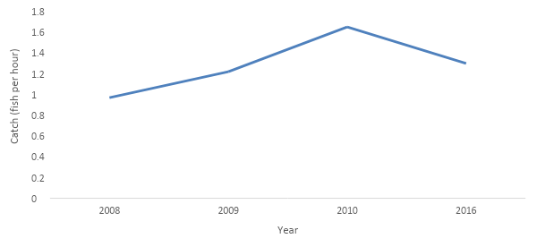
Figure 3. Spring gill net catch rates at Saguaro Lake for Yellow Bass between 2008 and 2016.

Figure 4. Mean spring electrofishing catch rates for Bluegill in Saguaro Lake between 2008 and 2019.

Appendices

Appendix A. Species, first and last year stocked, size (if known), number of stockings, and total number of fish stocked in Saguaro Lake from 1935 to 2014.
Species | 1st Year | Last Year | Size | # of Stockings | Total # Stocked
Black Crappie | 1935 | 1993 |  | 7 | 75,300
Bluegill | 1935 | 1956 |  | 33 | 648,493
Brown Trout | 1975 | 1975 | Fingerling | 1 | 7,836
Channel Catfish | 1948 | 1967 |  | 5 | 15,223
Coho Salmon | 1972 | 1972 | Fingerling | 1 | 29,998
Hybrid Sunfish | 1953 | 1953 |  | 2 | 20,342
Largemouth Bass | 1935 | 2009 | Fingerling/Subadult | 41 | 365,754
Rainbow Trout | 1966 | 2014 | Catchable | 119 | 294,872
Redear Sunfish | 1947 | 1953 |  | 2 | 55,400
Smallmouth Bass | 1941 | 2008 | Fingerling | 8 | 28,700
Walleye | 1973 | 2003 | Fry/Fingerling | 7 | 327,568

