Aerial or on-the-ground photos of the proposed project site.
After Hurricane Harvey in 2017, the materials from the original nursery were salvaged and moved to the new site at Texas Adaptive Aquatics property at 101 Atascocita Road, Huffman 77336. Pictured below the salvaged nursery boxes during the Summer of 2020. The wooden frames of the boxes are heavily damaged and beginning to fail. As such they can only support a few inches of water which is adequate for emergent species line spike rush and bulrush, but insufficient for submersed and floating-leaved species. Photos were from 2020 and the pictured plants were all killed during the 2021 winter storm.

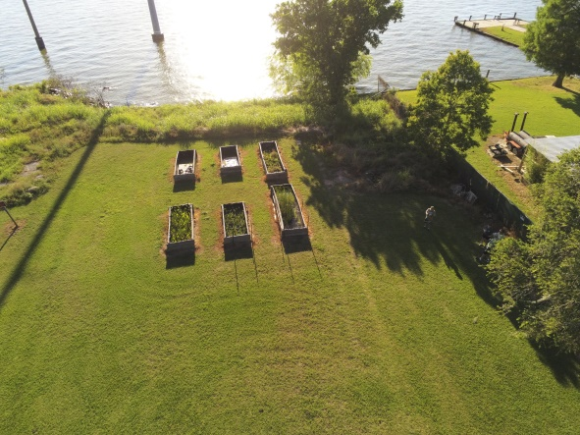 | 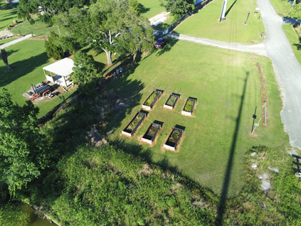
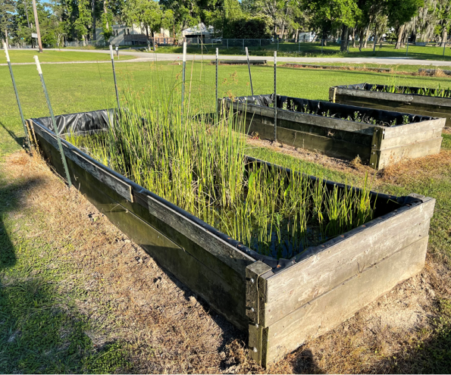 | 