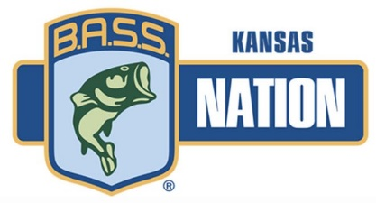
May 28, 2021
Reservoir Fish Habitat Partnership (RFHP)
Friends of Reservoirs

Dear Grant Application Committee Members,

The Kansas B.A.S.S. Nation (KBN) would like to acknowledge and support the grant request being submitted by the Kansas Department of Wildlife Parks & Tourism (KDWP&T) to secure a grant for the purchase of artificial fish habitat structures to be placed in public bodies of water across the state of Kansas.

KBN and its supporting clubs throughout the state have already agreed to donate the necessary man hours to assist KDWP&T in the placement of these unique habitat structures. KBN is excited to learn about the matching funds promised by KDWP&T to bolster the project’s scope.

KBN has a long-standing mission to improve fisheries habitat as part of our conservation promise and is excited to support this effort to obtain additional structures that will have a positive impact on Kansas fisheries.

Sincerely,
Dell Mettlen, Jr.
Dell Mettlen, Jr.
KBN Conservation Director

